**BRAZIL E-COMMERCE ANALYSIS REPORT**

**TIME SERIES ANALYSIS DASHBOARD**

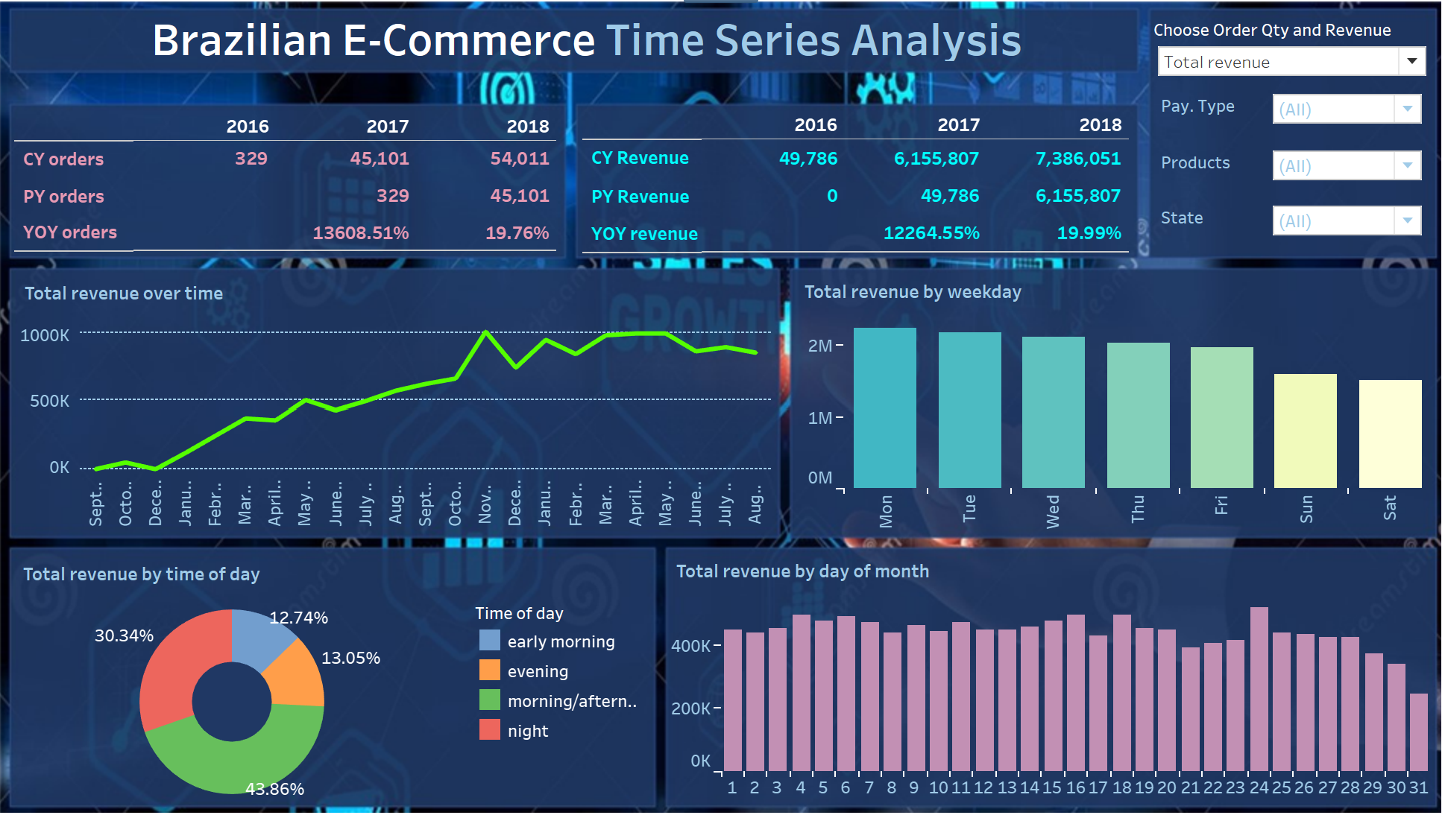

I.1 TOTAL ORDERS/REVENUE PER YEAR? YOY ORDERS/ REVENUE?

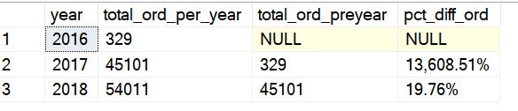

Total Revenue of 2017 & 2018? YOY Revenue change?

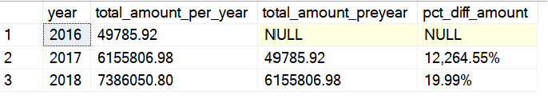

I.2 TOTAL ORDERS/ REVENUE OVER TIME 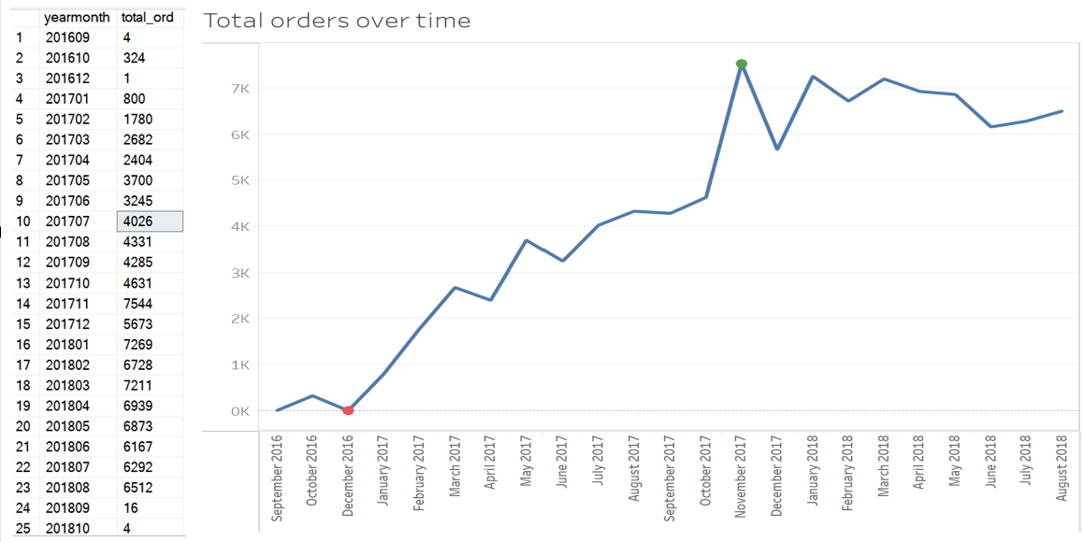

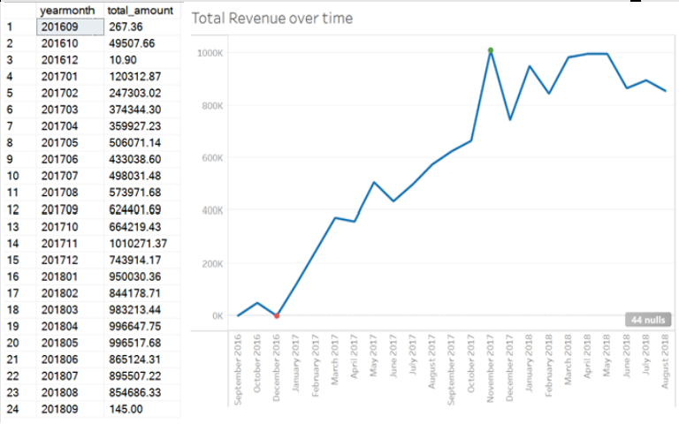

**Comments:**

So với năm 2016, năm 2017 tổng số lượng đơn hang cũng như doanh số tăng rất mạnh trên 10000%. Tuy nhiên sang năm 2018, những chỉ số này chỉ tăng 20% so với năm trước.. Tháng 9, 10 – 2018, doanh số và số lượng đơn hàng giảm đột biến do những chỉ số này đang tính trên một số ngày nhất định không phải tính tất cả các ngày trong tháng, nên có thể bỏ qua 2 tháng này khi dự đoán.

Thông qua những con số này, cần cân nhắc thay đổi chính sách tiếp cận khách hàng, các chương trình khuyến mãi, các chương trình quảng cáo (thay vì tập trung mạnh vào thu hút khách hàng mới như năm 2017, những năm sau đó nên tập trung để duy trì khách hàng hiện có để họ có những trải nghiệm, an toàn, nhanh chóng và tiện lợi nhất) …

**Analysis of Sales and Order Trends (2016-2018):**

**2016 vs. 2017:**

* In 2017, there was a remarkable surge in orders and sales, experiencing an extraordinary growth rate of over 10,000% compared to the previous year (2016).

**2017 vs. 2018**:

* Contrasting the substantial growth in 2017, 2018 witnessed a more moderate increase, with the total number of orders and sales rising by only 20% compared to the preceding year.

**September and October 2018 Anomaly:**

* A notable anomaly emerged in September and October 2018, marked by a sudden decline in both sales and order quantity. This can be attributed to the calculation of these metrics over specific days, excluding the entire month. Hence, it is advisable to exclude these two months when predicting future trends.

**Suggestions:**

* Considering these figures, there is a compelling case for reevaluating customer outreach policies, promotional programs, and advertising strategies. Rather than concentrating primarily on acquiring new customers, a strategic shift is recommended. Future efforts should be directed towards maintaining existing customers, ensuring they enjoy the most secure, efficient, and convenient experiences.

--I.3 TOTAL ORDERS/ REVENUE BY DAY OF MONTH

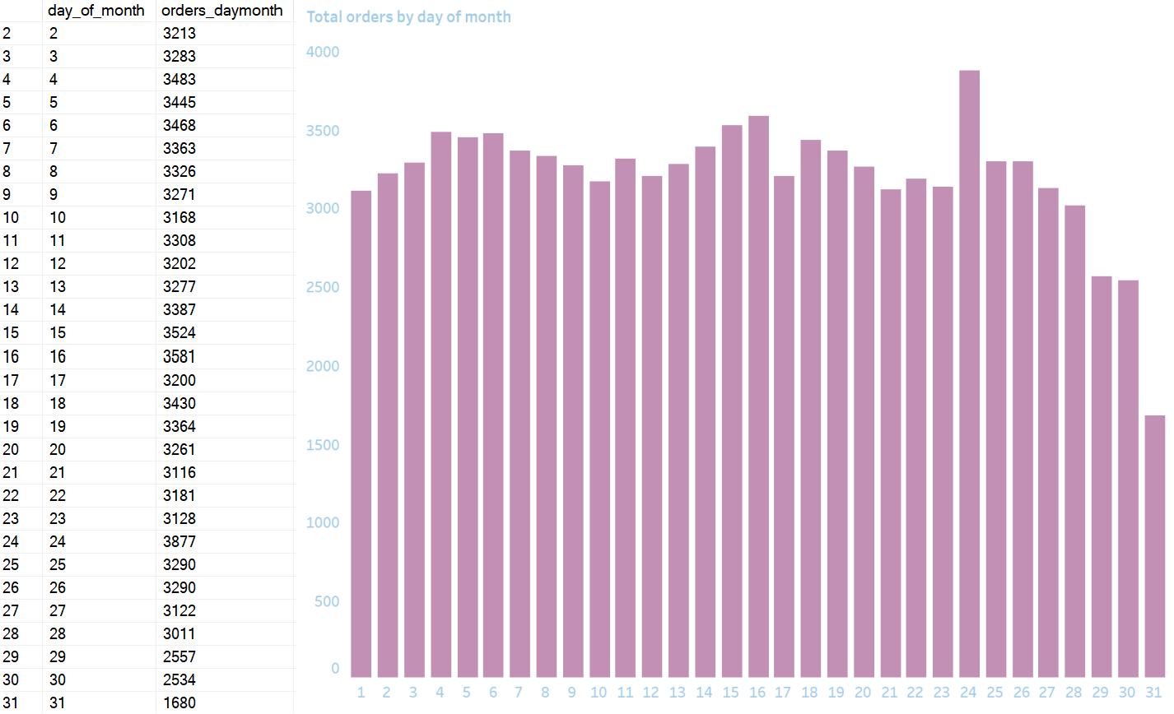

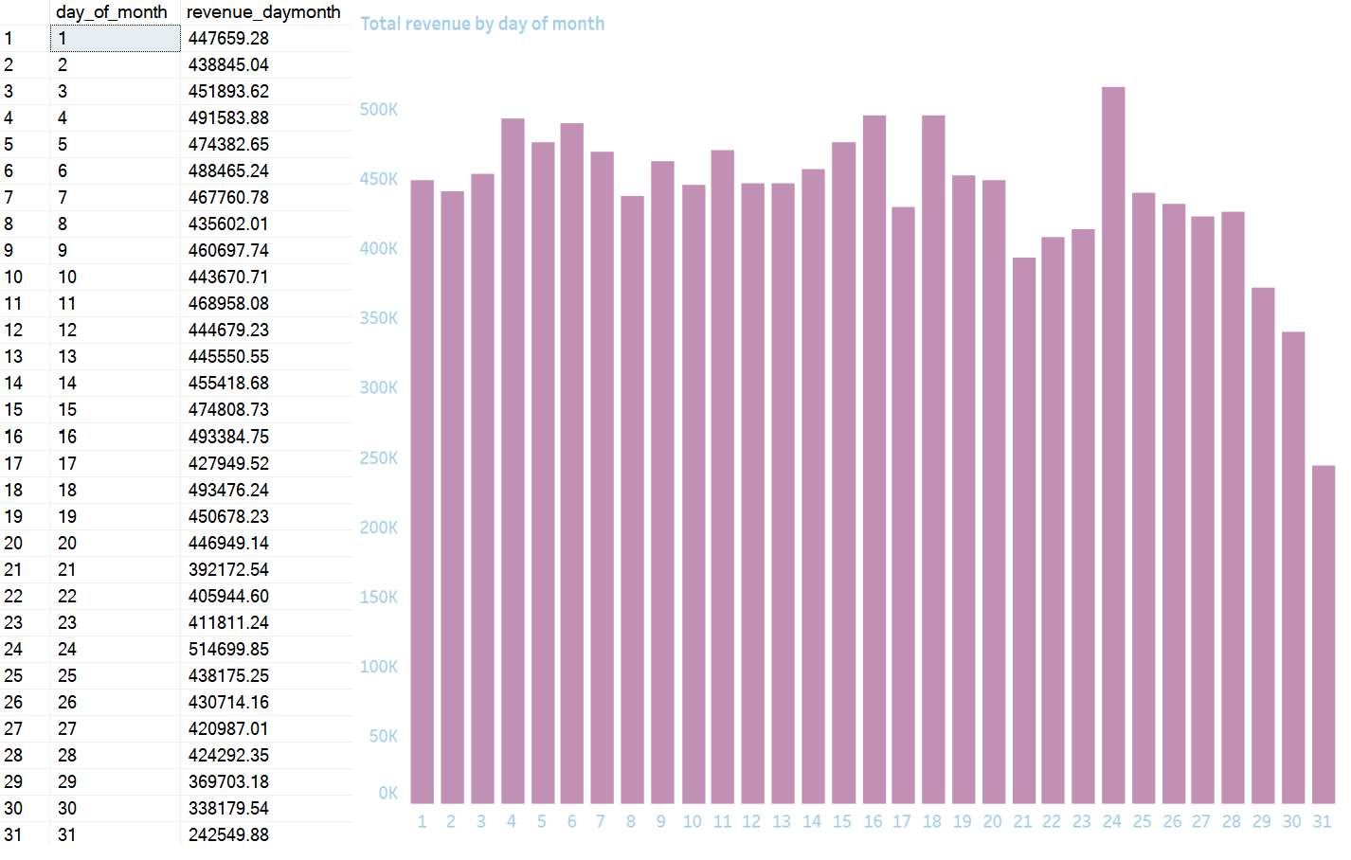

I.4 TOTAL ORDERS/REVENUE BY WEEKDAY

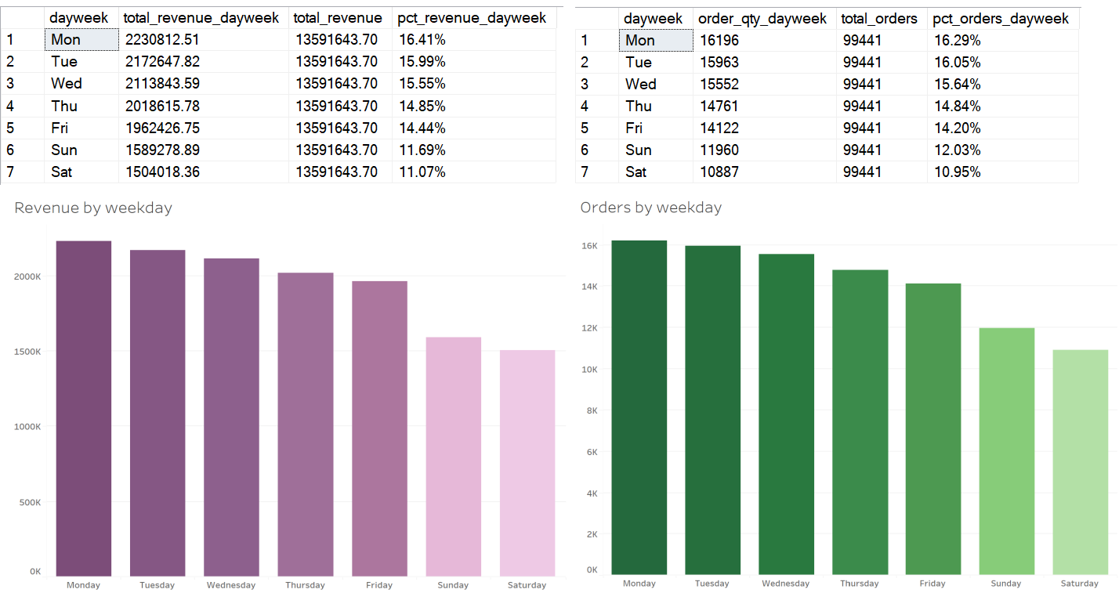

I.5 TOTAL ORDERS/ REVENUE BY TIME OF THE DAY

/*9 to 16 --> Morning/Afternoon

16 to 18 --> Evening

18 to 23 --> Night

23 to 9 --> Early Morning */

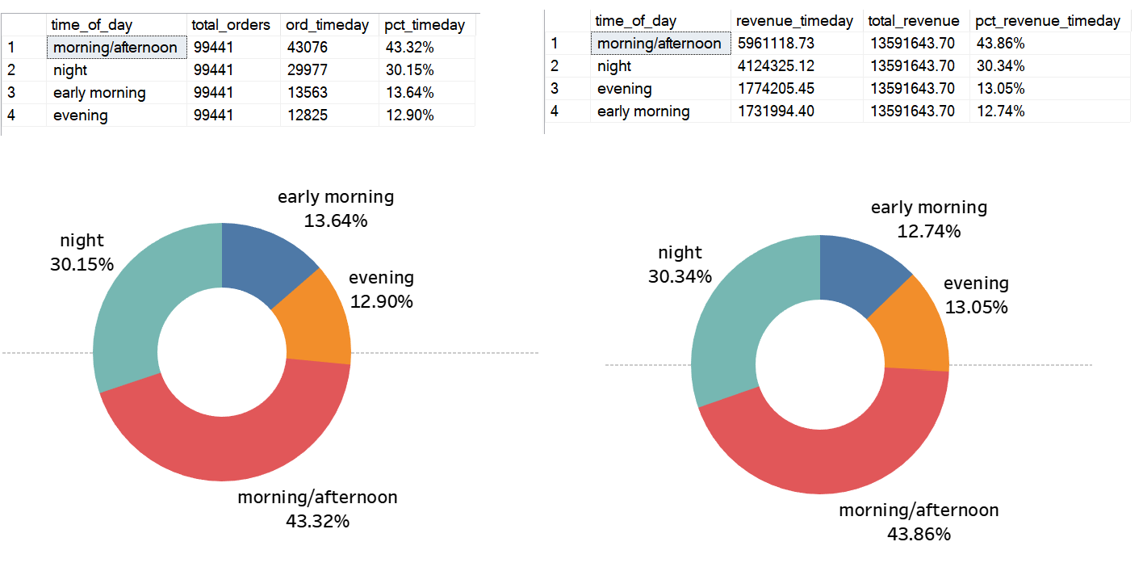

**Comments**:

Phân tích order_purchase_timestamp để biết được:

Trong một tháng, số lượng đơn hàng và doanh số thường tập trung vào những ngày nào? Những ngày cuối tháng số lượng đơn hàng và doanh thu sẽ giảm do hết tiền, những ngày sát với ngày nhận lương thì những chỉ số này sẽ cao

Trong một tuần, khách sẽ mua nhiều vào những ngày làm việc – từ thứ 2 đến thứ 6 để tiện nhận hàng và có nhiều thời gian để lướt web. Những ngày cuối tuần sẽ ít hơn do phải dành thời gian cho gia đình hoặc các dự án cá nhân khác.

Trong một ngày, những thời điểm nào khách sẽ mua nhiều. Ví dự như trong thờ gian làm việc ở công ty sẽ mua nhiều, thời gian chiều tối và đêm muộn hoặc gần sáng rất ít vì phải lo cơm nước vệ sinh cá nhân hoặc trong thời gian ngủ nghỉ.

Từ đó sẽ điều chỉnh các chính sách liên quan, ví dụ lựa chọn thời điểm nào nhiều người truy cập để đẩy mạnh quảng cáo, thời lúc nào ít tướng tác sẽ cắt giảm để tiết kiệm chi phí đồng thời tăng doanh thu và lợi nhuận.

**Analysis of order_purchase_timestamp:**

Examining the order_purchase_timestamp provides insights into the following patterns:

**Monthly Trends:**

* Within a month, the concentration of order quantity and revenue is notable on specific days. Towards the end of the month, there might be a decrease in the number of orders and revenue due to financial constraints. Conversely, close to payday, these metrics are expected to be higher as customers are likely to have more disposable income.

**Weekly Patterns:**

* Throughout the week, customers tend to make more purchases on working days (Monday to Friday) for the convenience of receiving orders and having ample time for online browsing. On weekends, there is a decline, likely attributed to dedicating time to family or other personal projects.

**Daily Buying Trends:**

* Within a day, certain time periods witness increased customer purchases. For instance, during working hours, there is a higher likelihood of buying. Evening and late night , as well as early morning, see fewer transactions, possibly due to attending to personal needs or during sleep hours.

**Suggestions:**

Adjustments to relevant policies can be made based on these findings. For instance, optimizing advertising during peak access times, cutting costs during less interactive periods to enhance cost-effectiveness, and ultimately boosting revenue and profitability.

**SEGMENTATION ANALYSIS DASHBOARD**

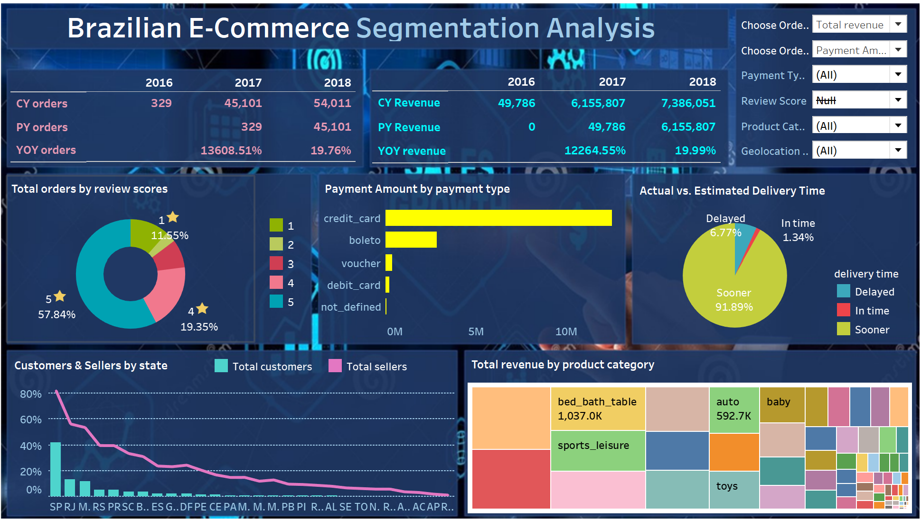

--II.1 TOTAL CUSTOMERS & SELLERS BY STATE

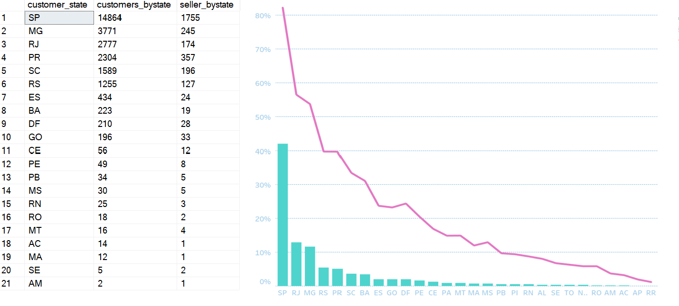

--II.2 TOTAL ORDERS/ PAYMENT AMOUNT BY PAYMENT TYPE

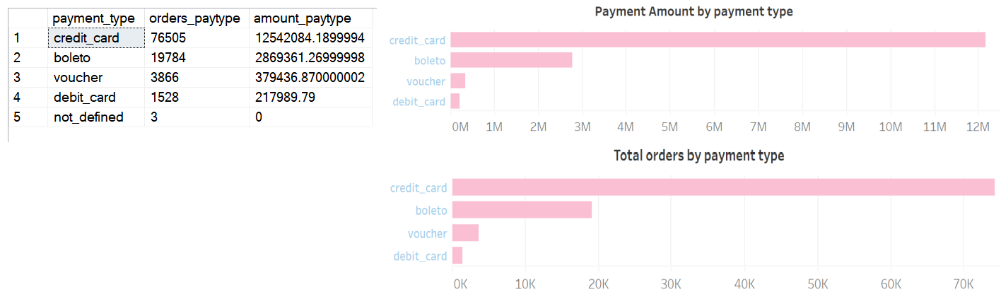

* Credit card transactions emerged as the most prevalent. Our strategic focus revolves around developing a dedicated application to facilitate seamless and unlimited bank-issued credit card payments. Collaboration with our banking partner is to not only reduce transactional costs but also to introduce attractive benefits and reward programs for customers utilizing credit card payments.
* Cash transactions also represented a significant portion. There is a consideration to enhance Cash on Delivery services, making the process more efficient and customer-friendly.
* Less common payment methods need gradually eliminated. This will reduce associated costs and simplify the payment landscape for both customers and the company.

--II.3 TOTAL ORDERS/ REVENUE BY REVIEW SCORES

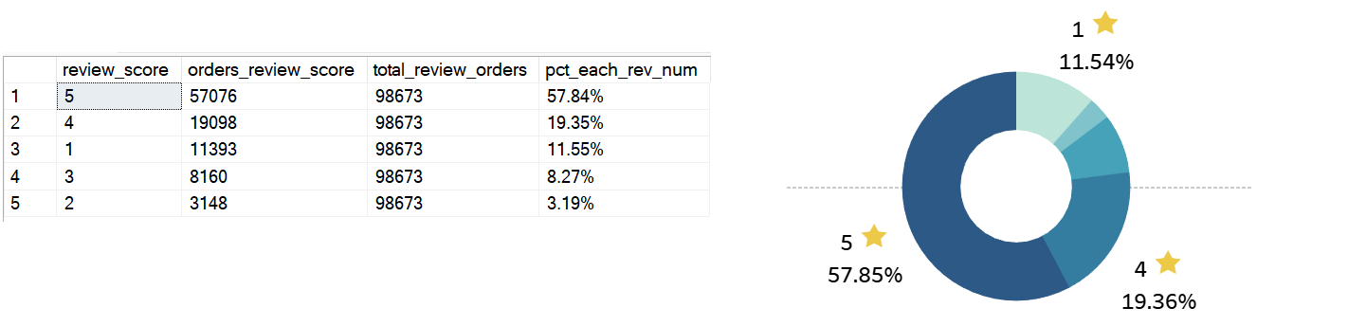

* 4-star and 5-star evaluations account for approximately 80% of the total. This is a positive indication of customer satisfaction. However, a closer look is warranted to understand the specific reasons behind 4-star evaluations. Identifying these factors will enable us to implement targeted strategies to elevate all ratings to the highest level, ensuring consistently exceptional customer experiences.
* A considerable number of orders are receiving 1-star ratings. It is necessary a thorough examination of customer service, delivery processes, product quality, and interactions with suppliers. Addressing issues related to inaccurate product descriptions, flawed return policies, and disrespectful employee attitudes is crucial to improve overall customer satisfaction.

--II.4 TOTAL ORDERS/ REVENUE BY PRODUCT CATEGORY

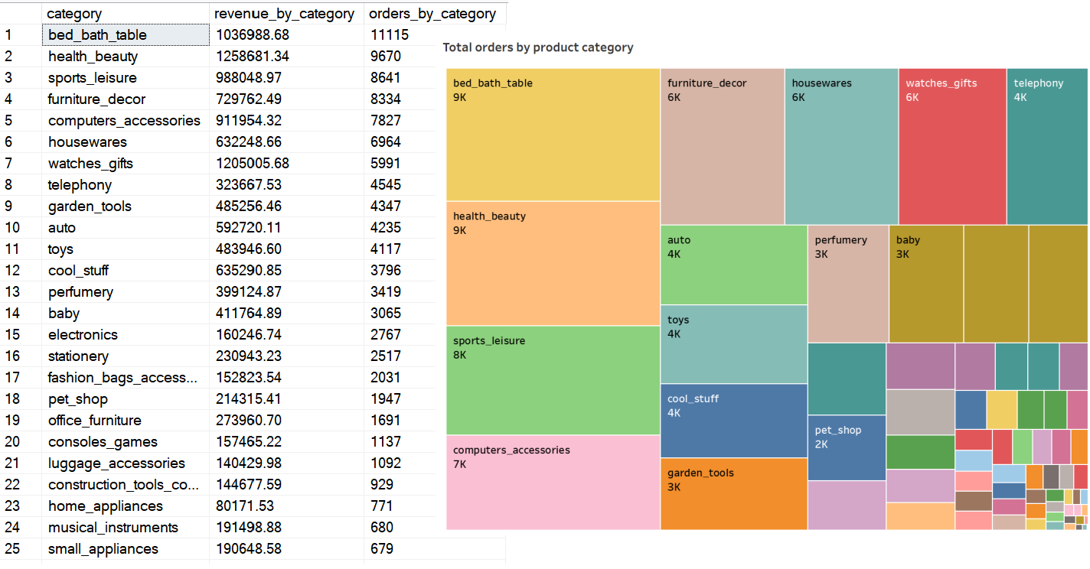

* An in-depth analysis reveals that customer preferences are concentrated on specific product categories. Understanding these preferences is crucial for optimizing the platform and creating an environment conducive to suppliers specializing in these favored products. Insights into customer buying behavior within these categories will guide targeted marketing efforts.
* With limited-purchase products on the e-commerce platform, an evaluation involves identifying reasons for limited sales, gauging market demand, and exploring avenues for improvement. By understanding the challenges these products face, we can implement strategies to boost their visibility and appeal.

--III.7 COUNT THE NUMBER ORDERS THAT WERE DELIVERED FASTER, IN TIME, SLOWER THAN ESTIMATED TIME

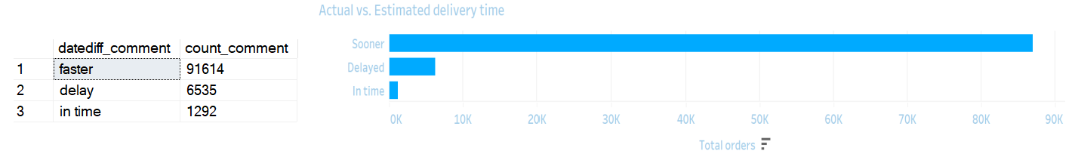

* A substantial portion of orders is consistently experiencing delays beyond the initially projected delivery dates. To identify the underlying causes of late deliveries, key areas of focus included order processing, logistics, transportation, and potential bottlenecks within the delivery chain.
* Several improvement strategies are recommended:
  + Streamlining order processing workflows to reduce internal processing time.
  + Enhancing logistics and transportation coordination for optimized route planning.
  + Implementing real-time tracking systems to identify and address delays promptly.
  + Conducting regular performance reviews and implementing key performance indicators (KPIs) for the delivery service provider.